In-Class Exercise
- Data on Obesity from the Muscatine Coronary Risk Factor Study.
Source: Table 10 (page 96) in Woolson and Clarke (1984).
Description: The data are from the Muscatine Coronary Risk Factor (MCRF) study, a longitudinal survey of school-age children in Muscatine, Iowa. The MCRF study had the goal of examining the development and persistence of risk factors for coronary disease in children. In the MCRF study, weight and height measurements of five cohorts of children, initially aged 5-7, 7-9, 9-11, 11-13, and 13-15 years, were obtained biennially from 1977 to 1981. Data were collected on 4856 boys and girls. On the basis of a comparison of their weight to age-gender specific norms, children were classified as obese or not obese.
Variable List:
ID, Gender (0=Male,1=Female), Baseline Age, Current Age, Occasion, Obesity Status.
Note 1: Obesity Status (1=Obese, 0=Non-Obese, .=Missing)
Note 2: Age denotes mid-point of age-cohort
Use the following code to read in data:
setwd("……/data")
cnames=c("id","gender","baseage","age","occasion","y")
ds <- read.table("muscatine.txt", col.names=cnames, na.strings = ".")
The goal of the analyses is to determine whether the risk of obesity increases with age and whether patterns of change in obesity are the same for boys and girls.
Answer the following questions:
- We set logitp=log(p/(1-p)). And the plot of logitp vs age by gender is in below. How would you comment on the curvature.

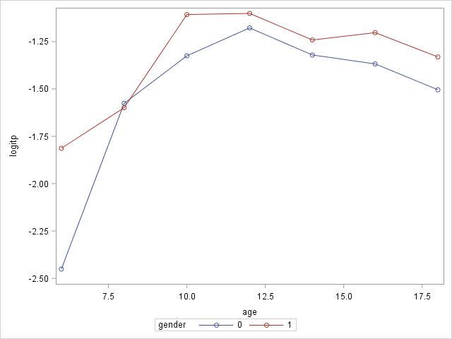

- Create a new variable centered age (cage=age-12) and its square (cage2=cage$×$cage).
- Fit a logistic marginal model for this longitudinal data with y as the response, gender as the time-invariant covariate, cage, cage2 as a continuous time-varying covariate, interaction between gender and cage, and interaction between gender and cage2. Write down the model equation in algebraic form.
- Assume the correlation structure is exchangeable. Report the parameter estimates table.
- What does the lack of interaction between gender and age mean?
- Since the interaction test was not significant, we dropped the two interaction terms from the model in d). Fit the resulting model and report the parameter estimates table.
- Interpret the coefficients of intercept and gender. What does a negative coefficient for cage2 mean?

